Chapter 3, Problem 36.

Use mesh analysis to obtain i₁ , i₂, and i₃ in the circuit in Fig. 3.84.

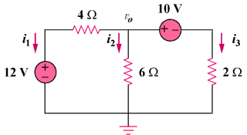

Figure 3.84
For Prob. 3.36.

